Classification of substances as elements, compounds or mixtures OC3 OC4
You have used techniques such as filtration, evaporation and distillation to separate mixtures.
- What have all mixtures got in common?

Substances that are not mixtures are called pure substances. Pure substances are either elements or compounds.
- Elements are substances that cannot be broken down chemically into other, simpler substances.
- Each element has a symbol, for example, H = hydrogen.
- All known elements are listed in the periodic table of the elements.

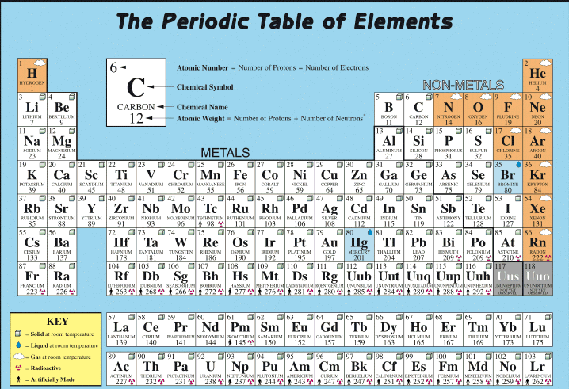

- What is the symbol for zinc?
- What is the symbol for oxygen?
- What is the symbol for copper?
- What element does the symbol Fe represent?
- What element does the symbol N represent?
- What element does the symbol S represent?

Compounds are pure substances that can be chemically broken down into simpler substances
- Compounds are pure substances formed from two or more different elements combined in a fixed proportion by mass.
- When a compound is formed from its elements, the compound usually has different properties to those of the elements from which it is formed. For example, sodium chloride (common salt) is a white solid which is relatively unreactive chemically. The elements from which it is formed are sodium, a very reactive silvery metal, and chlorine, a very reactive pale green gas.
- Each compound has a chemical formula, for example, NaCl = sodium chloride.
- Compounds are not listed in the periodic table of the elements.

- Sodium chloride is a compound. If it is broken down chemically, what elements are formed?
- Why is sodium chloride not listed in the periodic table of the elements?

To classify substances as elements compounds or mixtures, the following key may be useful.
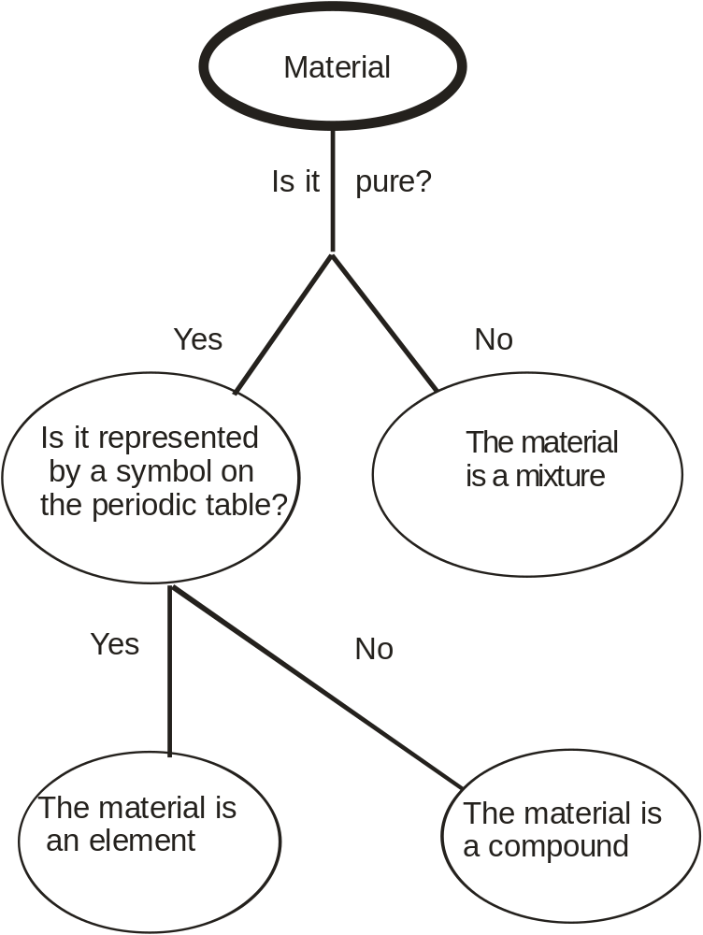

Use the key to classify materials as elements, a compounds or mixtures.

Substance | Element, compound or mixture?
Salt
Silver (Ag)
Oxygen
Sea water
Copper
Gravel
Hydrogen
Nitrogen
Carbon dioxide
Air
Water
Petrol
Sulfur
Carbon
Cola drink
Mercury (Hg)
Gold (Au)
Zinc
Iron filings
Aluminium
Copper sulfate
Rock salt

